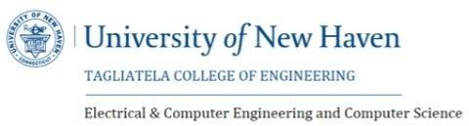

**LETTER OF TRANSMITTAL**

Team   
sallu8@unh.newhaven.edu  
203-435-3296

Feb 01, 2025

Dr.Mohsen Sarraf  
Data science  
University of New Haven  
300 Boston Post Road, CT

**SUBJECT** : Submission of Capstone Project Report on AI Resume Enhancer.

Dear Professor Mohsen Sarraf,

**AI Resume Enhancer Project**

The AI Resume Enhancer is an intelligent web-based platform developed to assist job seekers in refining and aligning their resumes with specific job roles. By leveraging cutting-edge technologies in machine learning and Natural Language Processing (NLP), the system evaluates a resume's relevance to a given job description, pinpoints missing industry-relevant keywords, and automatically improves the content to better match the role. Additionally, it offers job recommendations and actionable insights to increase visibility in applicant tracking systems (ATS), ultimately enhancing a candidate’s chances of securing interviews.

**Development & Implementation:**

To develop the AI Resume Enhancer, we combined multiple AI and web technologies to build an intelligent, user-friendly application. The resume evaluation process uses the **Sentence-BERT (all-MiniLM-L6-v2)** model to measure semantic similarity between resume content and job descriptions. For enhancing the text, we integrated **OpenAI's GPT-3.5-turbo** via API, which rewrites the resume by inserting missing keywords while maintaining a professional tone.

The web application is built using **Streamlit**, providing an interactive interface for uploading resumes, pasting job descriptions, and viewing enhancement results. Text extraction from uploaded PDF and DOCX files is handled using **pdfplumber** and **python-docx** libraries. Additionally, **Regex-based matching** is implemented to detect keyword gaps efficiently. We also integrated the **Adzuna Job Search API** to fetch real-time job listings based on extracted skills, enhancing the platform’s utility for users.

**Testing & Improvements:**

We tested the AI Resume Enhancer by analyzing various resumes against real job descriptions and comparing the enhancement output with manually tailored versions. The accuracy of keyword insertion and content alignment was validated through both automated similarity scoring and human feedback. The OpenAI-generated enhancements were reviewed for tone, relevance, and readability. We also tested the tool with different resume formats (PDF and DOCX) to ensure consistent performance. Several improvements were made to handle formatting inconsistencies and empty content edge cases. Overall, the system showed a marked improvement in ATS compatibility and job relevance.

Thank you for your time and consideration.

Sincerely,

Chaitanya Alluri

Renuka Gadde

Sai Teja Madiri

Apurva Ravikar Chavan

**University of New Haven**

**PROJECT REPORT**

**PROJECT NAME** : AI Resume Enhancer

# STUDENT NAMES : Chaitanya Alluri

# Renuka Gadde

# Sai Teja Madiri

# Apurva Ravikar Chavan

# COURSE NAME : Data Science

# COURSE CODE : DSCI-6051-05

# Professor Name : Mohsen Sarraf

# START DATE : FEB 01 – 2025

# END DATE : May 06 - 2025

# EXECUTIVE SUMMARY

**Project Title : AI Resume Enhancer**

**Basic Introduction :**

The AI Resume Enhancer project is about developing a web-based application that helps job seekers improve their resumes by making them more relevant to specific job roles. Resumes often lack the right keywords or structure needed to pass through **Applicant tracking systems (ATS)**. Our tool uses **Natural Language Processing (NLP)** and machine learning to analyze resumes and compare them with job descriptions. It identifies missing skills, improves wording, and ensures the content is professional and tailored. This helps users save time and increases their chances of getting noticed by recruiters and automated screening systems.

**Project Overview :**

The AI Resume Enhancer project is focused on building a **web-based tool** that helps users tailor their resumes to match specific job descriptions. It uses **Natural Language Processing (NLP) and machine learning** to analyze resumes, identify missing keywords, and enhance the content to improve job relevance. The tool supports PDF and Word files, making it easy for users to upload and optimize their documents. The project follows a structured workflow that includes resume parsing, similarity scoring, AI-based rewriting, and user interface development to ensure accurate and user-friendly results.

**1. Data Preparation**

* Collected a **diverse set of resumes and job descriptions** from industries like **IT, marketing, and finance**.
* Used **pdfplumber** and **python-docx** to **extract content** from uploaded **PDF and DOCX files**.
* **Cleaned the extracted text** by removing unnecessary formatting, extra whitespace, and non-informative characters.

**2. Data Analysis**

* Analyzed **resume and job description structures** to identify key components such as **“Skills,” “Experience,”** and **“Education.”**
* **Segmented content** for uniform processing and better **keyword extraction**.
* Used **Regex** to detect **critical keywords and phrases** missing from resumes compared to job descriptions.

**3. Model Integration**

* Integrated the **Sentence-BERT** model to compute **semantic similarity** between resume and job description text.
* Used **OpenAI’s GPT-3.5-turbo API** to generate **enhanced, keyword-rich resumes** while preserving professional tone.
* Applied **classification logic** to score **skills, experience**, and **education match levels**.

**4. Performance Check**

* Compared **AI-generated resumes** with **manually optimized** ones to verify **quality and clarity**.
* Evaluated **output accuracy** using **similarity scoring, keyword presence**, and **readability.**
* Improved **enhancement logic and formatting** based on **test results** and **user feedback**.

**5. App Integration**

* Developed the **front-end using Streamlit** for **easy interaction, resume upload**, and **real-time enhancement**.
* Implemented **keyword visualization**, **similarity scores**, and **download options**.
* Integrated the **Adzuna API** to fetch **real-time job listings** based on **resume keywords**.

**Key Results :**

The **AI Resume Enhancer** helps users create **job-targeted, professional resumes** more efficiently. Key advantages include:

* **Accuracy** – Matches resumes with job descriptions and **adds missing, relevant keywords** intelligently.
* **Fewer Errors** – Uses **semantic analysis** and **Regex** to **identify and fill missing skills or qualifications**.
* **Speed & Efficiency** – Reduces time spent on resume tailoring by **automating the enhancement process**.
* **User-Friendly** – Clean **UI with instant feedback**, resume previews, and **downloadable results**.

**Cost Analysis :**

To keep the project **budget-friendly**, we used efficient tools and APIs:

* **Computing Power** – Mid-tier systems (**16GB–32GB RAM**) for development and testing; estimated cost: **$200–$600**.
* **Software & Tools** – **Open-source libraries** like **Streamlit, joblib, pdfplumber**; OpenAI API: **~$20/month**.
* **Time Taken** – Entire project (including **testing, development, and reporting**) took **100–150 hours**.

**Project Schedule :**

|  |  |
| --- | --- |
| **Phase** | **Duration** |
| Problem Definition & Data Collection | 10 to 15 hours |
| Data Preprocessing & EDA | 25 to 35 hours |
| Model Training & Optimization | 30 to 45 hours |
| Model Evaluation & Testing | 25 to 35 hours |
| Report Compilation & Deployment Planning | 10 to 40 hours |

# ACKNOWLEDGEMENT

# I am immensely thankful to the University of New Haven for offering the academic resources and technical infrastructure that made this project possible. I am especially grateful to Dr. Mohsen Sarraf, whose expert mentorship and continuous encouragement were instrumental in navigating the complexities of the AI Resume Enhancer from start to finish.

# I would like to express my sincere appreciation to our academic sponsors for their invaluable support throughout this project. Their assistance enabled access to essential technologies, APIs, and computational tools necessary for the development and testing of the AI Resume Enhancer. These resources played a crucial role in ensuring the performance, accuracy, and usability of the system. I am also thankful to the faculty and research staff at the University of New Haven for fostering a collaborative learning environment and providing guidance that helped us navigate technical challenges and refine the application effectively.

# A special note of appreciation goes to my colleagues and friends for their consistent encouragement and support throughout this journey. Their shared insights, constructive feedback, and thoughtful reviews significantly contributed to improving the quality and direction of the AI Resume Enhancer project. Working alongside them provided not only technical clarity but also much-needed motivation during challenging phases. Their involvement played a key role in refining both the concept and execution of this work. I am truly grateful for their presence and collaboration every step of the way.

# I am deeply indebted to my family for their unwavering support, understanding, and motivation throughout the project. Their belief in my capabilities kept me focused and determined.

# Lastly, I extend my thanks to the open-source developer community, whose contributions in the form of tools, libraries, and documentation served as a strong foundation for building this AI-powered application.

# Table of Contents

**Chapter 1 – Introduction**

* Overview of AI Resume Enhancer
* Importance of Resume Optimization
* Challenges in Resume Personalization
* Project Objectives
* Methodology Overview
* Scope and Limitations of the Project

**Chapter 2 – Problem/Project Definition**

* 2.1 Introduction to the Problem
* 2.2 Problem Statement
* 2.3 Objective of the Project
* 2.4 Scope of the Project
* 2.5 Significance of the Study
* 2.6 Expected Outcomes

**Chapter 3 – Evaluation of Alternatives**

* 3.1 Overview of Existing Resume Enhancement Methods
* 3.2 Comparison of Different NLP and AI Models
* 3.3 Challenges and Limitations of Existing Solutions

**Chapter 4 – Design Approach**

* 4.1 Data Collection and Preparation
* 4.2 Feature Extraction and Keyword Analysis
* 4.3 Model Architecture for Resume Enhancement
* 4.4 Evaluation Strategy and Scoring Logic
* 4.5 User Interface and System Workflow Design
* 4.6 Tools and Technologies Used

**Chapter 5 – Implementation and Code Explanation**

* 5.1 Technology Stack Overview
* 5.2 Module-Wise Breakdown of the Application
* 5.3 Streamlit Interface Structure
* 5.4 Resume Upload and Parsing Functionality
* 5.5 Resume Output Formatting and Download Option

**Chapter 6 – Design Narrative and Verification**

* 6.1 Model Development Lifecycle
* 6.2 Data Preprocessing and Cleaning for Resumes
* 6.3 Resume-Job Matching Model
* 6.4 Validation and Output Testing
* 6.5 System Accuracy and Enhancement Verification
* 6.6 Challenges Encountered During Development

**Chapter 7 – Discussion and Test Cases**

* 7.1 Interpretation of Enhancement Results
* 7.2 Model Performance and Similarity Scoring
* 7.3 System Limitations and Edge Cases
* 7.4 Comparison with Manual and AI Resume Builders
* 7.5 Future Improvements for AI Resume Enhancer
* 7.6 Test Case Scenarios and Results

**Chapter 8 – Conclusions and Recommendations**

* 8.1 Summary of Key Outcomes
* 8.2 Final Conclusions of the Study
* 8.3 Recommendations for Job Seekers and Career Services
* 8.4 Future Scope and Research Suggestions
* 8.5 Practical Applications and Industry Use Cases

**Chapter 9 – References / Citations**

* 9.1 Books and Academic Journals
* 9.2 Online Tools, APIs, and Documentation
* 9.3 Research Articles and Technical Papers

**Chapter 10 – Appendices**

* 10.1 Final Resume Enhancement Output Samples
* 10.2 Additional Documentation and Screenshots

**1. INTRODUCTION**

**Introduction to AI Resume Enhancer**

Resumes are essential documents in any job application process, but crafting one that stands out can be challenging. Many job seekers struggle with tailoring their resumes to meet specific job requirements or pass through automated systems like Applicant Tracking Systems (ATS). These systems filter out resumes that don’t contain job-relevant keywords or proper formatting, causing even qualified candidates to be overlooked. The AI Resume Enhancer helps solve this issue by using artificial intelligence to analyze, improve, and align resumes with job descriptions quickly and accurately.

**Overview of AI Resume Enhancer**

AI Resume Enhancer is a smart, web-based application that improves resume content by identifying keyword gaps, rewriting sections, and offering suggestions based on job descriptions. It uses Natural Language Processing (NLP) and machine learning models to understand the structure of resumes, extract key information, and ensure that the resume matches the language and requirements of a job posting. This makes the resume more attractive to recruiters and more likely to pass ATS screening.

**Significance of Resume Enhancement**

Enhancing resumes is crucial in today’s competitive job market. Here's why it's important:

* **Relevance**: Ensures that resumes contain the specific skills and keywords employers look for.
* **ATS** **Compatibility**: Increases the chance of a resume passing through automated filters.
* **Time**-**Saving**: Saves candidates time by automating tailoring for different job roles.
* **Accessibility**: Makes resume improvement easy for users with limited technical or writing skills.
* **Professionalism**: Improves tone, phrasing, and formatting to meet industry standards.

**Challenges in Resume Enhancement**

While enhancing resumes with AI offers many benefits, it comes with a few challenges:

1. **Varied Formats**: Resumes come in different layouts, structures, and file types (PDF, DOCX), which can complicate parsing.
2. **Context Understanding**: The AI must understand not just words but the meaning behind experience and skills to suggest improvements.
3. **Maintaining Originality**: Enhancements must keep the user’s voice and intent intact while still making improvements.
4. **Keyword Identification**: Accurately extracting relevant keywords from diverse job descriptions is a complex task.
5. **User Trust**: Users must feel confident that the suggestions truly improve their chances without distorting their qualifications.

**Project Objectives**

The primary goal of this project is to help users create impactful, job-targeted resumes with the help of AI. Specific objectives include:

1. **Build an Intelligent Web App**: Allow users to upload resumes and job descriptions for automated analysis.
2. **Enhance Resume Quality**: Suggest missing keywords and rephrase content using NLP models.
3. **Improve ATS Compatibility**: Help resumes align with recruiter expectations and filtering algorithms.
4. **Simplify the Process**: Provide users with a fast, easy-to-use tool for generating optimized resumes.
5. **Suggest Job Matches**: Use resume content to recommend relevant job opportunities via API integration.

**Methodology Overview**

This project follows a structured development methodology:

1. **Data Collection**: Collected real resumes and job descriptions from different industries.
2. **Text Extraction**: Used tools like pdfplumber and python-docx to extract resume content.
3. **Semantic Analysis**: Implemented Sentence-BERT to measure the match between resumes and job descriptions.
4. **Keyword Gap Detection**: Identified missing or underused keywords relevant to the job role.
5. **AI-Based Rewriting**: Integrated OpenAI’s GPT to enhance resume sections with missing content.
6. **Frontend Development**: Used Streamlit to build a clean, responsive user interface.

**Scope and Limitations of the Project**

**Scope:**

1. **Real-World Application**: Useful for job seekers across multiple industries such as tech, finance, marketing, etc.
2. **Interactive Interface**: Provides resume upload, enhancement suggestions, and download options.
3. **Job Search Integration**: Matches resume keywords to live job postings via the Adzuna API.

**Limitations:**

1. **File Format Dependency**: Currently optimized for text-based PDFs and DOCX files only.
2. **Language Support**: Focused on English-language resumes and job descriptions.
3. **Limited Personalization**: Enhancements are based on algorithmic patterns and may need user review for tone.
4. **Scanned Document Limitation**: The system cannot extract content from image-based or poorly scanned resumes without OCR.

**Wrapping It Up**

AI Resume Enhancer is a smart and practical solution for anyone looking to improve their job applications. By combining advanced AI models with an easy-to-use interface, the tool makes resume optimization fast, accurate, and accessible. Whether you're applying for your first job or transitioning careers, this platform helps you stand out by enhancing your resume with relevant keywords and professional language. It saves time, improves your chances with applicant tracking systems (ATS), and brings confidence to your job search. It's a game-changer for today’s competitive hiring landscape.

**User Interface screenshot**

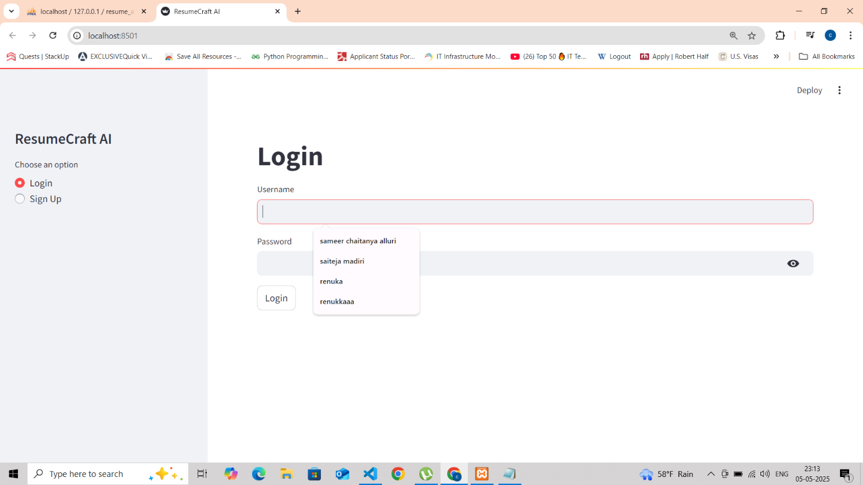

**Final Output Description**

The final output of the **AI Resume Enhancer** system is a clean, user-friendly web interface that enables job seekers to optimize their resumes for specific job roles. It simplifies the resume tailoring process by analyzing both the uploaded resume and the job description, then generating a revised version enhanced with job-relevant keywords and improved phrasing. The application supports both **PDF and Word (.doc/.docx)** file uploads, providing flexibility for users to submit their existing resumes in commonly used formats.

**Process of the Project**

**• Upload Options (PDF & Word):**  
Users can upload their resume files in **PDF** or **Microsoft Word** format either by dragging and dropping or browsing their local device. The system supports files up to 200MB in size for smooth and flexible input handling.

**• Job Description Input:**  
A text box allows users to paste a job description from any job portal. This description is used as the reference against which the resume will be evaluated and optimized.

**• One-Click Resume Analysis:**  
Once the resume and job description are submitted, users can click the **“Enhance Resume”** button. The system uses semantic similarity and NLP models to evaluate and score the match between the two.

**• Resume Enhancement Output Panel:**  
The right-hand side of the interface displays the results, including:

* **Similarity Score** – Indicates how closely the resume matches the job description.
* **Missing Keywords** – Lists important keywords found in the job post but missing in the resume.
* **Enhanced Resume Content** – An AI-generated version of the resume with improved phrasing and inserted relevant keywords.

**• Enhanced Resume Preview and Download:**  
Users can preview the revised resume directly on the screen and download it in **Word (.docx)** format with a single click for easy submission to employers.

**• Side-by-Side Comparison (Optional):**  
An optional feature allows users to view their **original resume** alongside the **enhanced version**, highlighting the improvements and changes made by the system.

**2. Problem/Project Definition**

**Introduction to the Problem**

In today’s highly competitive job market, resumes play a crucial role in securing employment. However, many applicants struggle to tailor their resumes to specific job descriptions, resulting in poor matches with employer expectations. Most companies use **Applicant Tracking Systems (ATS)** to filter resumes based on keyword relevance and formatting, which makes passing the initial screening a significant challenge.

Crafting an effective, job-specific resume manually is **time-consuming**, prone to **human error**, and requires a deep understanding of the job market and resume writing best practices. This becomes an obstacle for individuals trying to apply for multiple roles efficiently. The **AI Resume Enhancer** project addresses this issue by using **Natural Language Processing (NLP)** and **machine learning** to analyze and enhance resumes for better job compatibility.

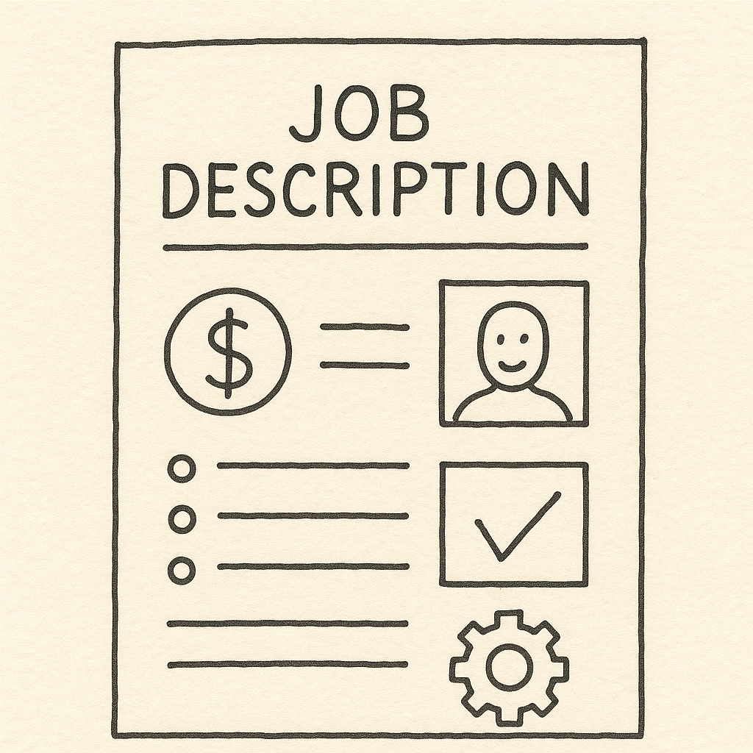

**Problem Statement**

Job seekers often submit resumes that do not align with the specific language or expectations of job postings. Manually customizing each resume to match job descriptions—by identifying missing keywords, adjusting phrasing, and maintaining professional tone—is both tedious and inefficient.

The lack of an **automated enhancement tool** leads to resumes being rejected by ATS filters despite candidates being qualified. There is a clear need for an **intelligent system** that can extract relevant information from job descriptions, analyze a resume's content, and suggest improvements or rewrite sections to better fit the job criteria.

**Objective of the Project**

The primary goal of the project is to:

* Design and implement a web application that enhances resumes to match job descriptions.
* Enable users to upload resumes in PDF or Word format and paste job descriptions into the application.
* Automatically analyze and extract key differences between the resume and job description.
* Generate an enhanced version of the resume with keyword-rich content and improved structure.

**Key capabilities include:**

* Identifying and suggesting missing skills, qualifications, or job-specific phrases.
* Providing a similarity score and keyword analysis to show alignment between resume and job post.
* Offering a downloadable enhanced resume in Word format.
* Optional integration of a job search assistant using real-time job listings based on resume content

**Scope of the Project**

This project focuses on developing a resume enhancement tool optimized for job seekers across multiple industries.

**Scope includes:**

* A web-based application using Streamlit for front-end design and Python NLP libraries (such as Sentence-BERT and OpenAI's GPT) for processing.
* Support for both PDF and Word (.docx) resume uploads.
* Implementation of semantic similarity scoring between resume and job description using Sentence-BERT.
* Use of OpenAI GPT-3.5-turbo for generating enhanced resume content.
* **A clean UI with:**
  + Tabbed navigation (Resume Upload, Job Description, Results)
  + Downloadable enhanced resume output
  + Visualization of similarity score and missing keywords
* **Basic error handling for:**
  + Empty or unsupported files
  + Short or generic job descriptions
  + Improper formatting

Though initially designed for English resumes and general job roles, the architecture can later be extended to include multilingual support and domain-specific resume optimization (e.g., healthcare, academia, tech).

**Significance of the Study**

The proposed AI Resume Enhancer system provides significant value in academic, personal, and professional settings:

* **Efficiency**: Reduces the time spent on resume editing by automating keyword matching and rewriting.
* **Accuracy**: Improves chances of ATS selection by inserting relevant keywords with high precision.
* **Accessibility**: Makes resume improvement approachable for non-technical users with little or no resume writing experience.
* **Innovation**: Combines NLP, ML, and UI design into a practical AI-driven tool with real-world use cases.
* **Scalability**: The underlying models and architecture can be adapted for other use cases such as cover letter generation, portfolio enhancement, or academic CV writing.

**Expected Outcomes**

The goal of the **AI Resume Enhancer** project is to simplify the process of tailoring resumes to specific job descriptions by using AI to automatically analyze, improve, and reformat the content in a structured and professional manner.

Once a user uploads a resume in PDF or Word format and provides a job description, the system processes the inputs to generate an enhanced resume and a summary report. The results include a similarity score, missing keyword list, and an improved version of the resume, which can be downloaded in a ready-to-use format.

By the end of this project, the following outcomes are expected:

* A fully functional **web application** that supports **PDF and Word** resume uploads.
* An **intuitive user interface** for analyzing, enhancing, and downloading optimized resumes.
* **Keyword extraction and content enhancement** using NLP models like Sentence-BERT and GPT-3.5.
* A **structured feedback panel** displaying similarity scores and keyword match insights.
* **Documented testing** across different resume styles and job domains to validate performance.
* A scalable foundation for future enhancements such as **cover letter generation** or **multilingual support**

**Key Features – Expected Outcomes**

* **Resume Upload Functionality**: Users can drag and drop or browse files to upload resumes (up to 200MB) in PDF or DOCX format.
* **Job Description Input Field**: Allows users to paste job postings directly from platforms like LinkedIn or Indeed.
* **Automated Resume Analysis**: The system compares resume content with the job description to identify.
  + Missing keywords and skills
  + Content alignment with job requirements
  + Sections requiring enhancement
* **Enhanced Resume Output:**
  + Displays rephrased content with job-relevant terminology
  + Highlights improvements in skills, experience, and education sections
  + Provides a downloadable version in Word (.docx) format
* **Similarity Scoring and Insights Panel:**
  + Shows a percentage-based match score
  + Lists missing or underrepresented terms
  + Offers improvement tips
* **Clean User Interface:** A modern, easy-to-use layout where users can:
  + View the original and enhanced resume side-by-side
  + Navigate between tabs for upload, analysis, and download
* **Enhanced User Experience:** Saves time and boosts confidence by automatically tailoring resumes to match job roles—without needing professional writing skills.

**3. Evaluation of Alternatives**

* **A Simple Overview of Resume Enhancement Methods**

In recent years, tailoring resumes to job-specific roles has become increasingly important — and challenging. Job descriptions often contain specific keywords and phrasing that recruiters and Applicant Tracking Systems (ATS) look for. Reading job descriptions, analyzing them, and editing resumes manually is time-consuming. Luckily, Natural Language Processing (NLP) and AI technologies have opened the door for smart, automated resume enhancement. Here's a simple breakdown of the core approaches:

* **Rule-Based Methods**
* This traditional method involves identifying specific patterns and keywords in both resumes and job descriptions using tools like regular expressions.
* **Pros:** Easy to set up, interpretable, and accurate when the structure is known.
* **Cons:** Limited flexibility, manual updates required, and ineffective for unfamiliar resume formats.
* **Extractive Keyword Matching**
* This method pulls out relevant phrases or sections from resumes that directly match job descriptions, often used in simple keyword analysis tools.
* **Pros:** Fast and simple; no training needed.
* **Cons:** May miss deeper semantic relevance and offer fragmented suggestions.
* **Abstractive Enhancement (Deep Learning)**
* This involves understanding resume content and rewriting or suggesting changes using deep learning models like GPT or T5.
* **Pros:** Generates polished, natural suggestions.
* **Cons:** Requires substantial data and computational power; potential risk of irrelevant generation.
* **Transformer-Based Models**
* Advanced models like **Sentence-BERT**, **OpenAI GPT-3.5**, or **T5-small** provide high flexibility and semantic matching for resume-job alignment.
* **Pros:** Highly contextual and accurate for keyword and content enhancement.
* **Cons:** Requires tuning and high memory; API usage can be costly.
* **Commercial APIs (OpenAI, Google NLP, AWS Comprehend)**
* These services allow easy integration and use of pretrained NLP models.
* **Pros:** Easy to implement, reliable performance.
* **Cons:** Limited customization, potential cost, and data privacy considerations.

**Criteria for Evaluation**

To choose the right resume enhancement approach, the following criteria are used:

* **Accuracy and Relevance** of enhanced content
* **Speed and resource usage** during processing
* **Customization ability** to adapt to various industries
* **Ease of integration** with web apps and user flows
* **User experience** and readability of suggestions
* **Robustness and error handling**

|  |  |  |  |  |
| --- | --- | --- | --- | --- |
| **Criteria** | **Rule**-**Based** | **Extractive** | **T5-small / GPT** | **Commercial APIs** |
| Accuracy | Medium | Medium | High | High |
| Customization | High | Low | High | Medium |
| Performance (Speed) | High | High | Medium | High |
| Resource Requirements | Low | Low | High | Medium |
| Web Integration Ease | Easy | Easy | Moderate | Easy |
| Quality of Suggestions | Low-Medium | Medium | High | High |
| Cost | Free | Free | Free / Paid | Paid |

**Comparison of NLP Models for Resume Enhancement**

**A. Rule-Based Techniques**

* **Type:** Extractive
* **Pros:** Simple, interpretable, low resource usage
* **Cons:** Not adaptable, limited accuracy, needs constant updates

**B. Extractive Models (TextRank, LexRank)**

* **Type:** Extractive
* **Pros:** Lightweight, fast, no training needed
* **Cons:** Lacks coherence, weak in semantic matching

**C. Transformer-Based Models**

**T5-small**

* **Type:** Abstractive
* **Pros:** Flexible, text-to-text format, suitable for legal and structured resume content
* **Cons:** Requires GPU, needs fine-tuning for high accuracy

**BART**

* **Type:** Abstractive
* **Pros:** High-quality output, strong pretrained foundation
* **Cons:** Larger size, slower inference, high computation

**D. GPT-3 / GPT-4 via API**

* **Type:** Abstractive
* **Pros:** Context-aware, natural suggestions, minimal setup
* **Cons:** API cost, output control limitations, sensitive data risk

**📊 Summary Comparison of Model**

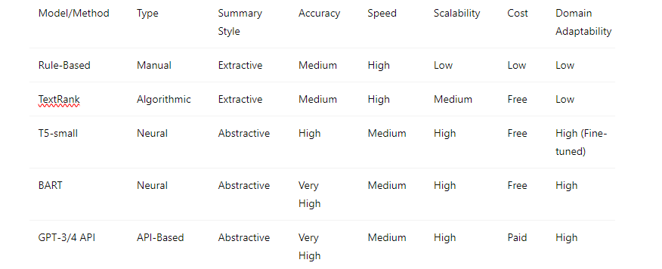

**3.3 Evaluation Metrics for Resume Enhancement Quality**

To assess the performance of resume enhancement models, both automated metrics and human evaluation are used.

* **ROUGE (Recall-Oriented Understudy for Gisting Evaluation)**
* **ROUGE-1:** Matches individual words
* **ROUGE-2**: Matches bigrams
* **ROUGE-L**: Longest common sequence
* **✅ Pros**: Numeric comparison; consistent testing
* **❌ Cons**: Focuses on words, not meaning
* **BLEU (Bilingual Evaluation Understudy)**
* **✅ Pros**: Good for short summaries; easy to compute
* **❌ Cons**: Penalizes paraphrasing; lacks semantic understanding
* **BERTScore**
* **✅ Pros**: Measures contextual similarity and meaning
* **❌ Cons:** More computationally heavy; model-dependent results
* **Human Evaluation**
* **Relevance:** Does the suggestion match the job role?
* **Coherence:** Are the enhancements logically structured?
* **Fluency:** Is the language professional and natural?
* **Faithfulness**: Does it stay true to original content?
* **ATS Compatibility:** Is the output likely to pass job filters?
* ✅ **Pros:** Offers deep qualitative insight
* ❌ **Cons:** Time-consuming and subjective

**4. Design Approach**

* **Data Collection and Preparation**

The success of an AI-based resume enhancement system depends heavily on the quality and diversity of the input data. For this project, a variety of **real-world resumes and job descriptions** were collected from public datasets, career websites (such as LinkedIn and Indeed), and anonymous university placement portals. The documents varied in format, structure, industry focus, and content length.

To ensure consistent input for model processing and evaluation, the following **preprocessing steps** were performed:

* **Text Extraction**: Used pdfplumber and python-docx to extract clean text from **PDF and DOCX** files.
* **Data Cleaning**: Removed headers, footers, special formatting characters, and irrelevant whitespace.
* **Section Tagging**: Manually labeled key sections such as **“Skills,” “Work Experience,” “Education,”** and **“Summary.”**
* **Tokenization**: Used **spaCy** and **NLTK** to split resumes and job descriptions into sentences and words.
* **Normalization**: Converted text to lowercase, removed stop words, and standardized dates and job titles.

This preparation enabled better **clause detection**, **semantic comparison**, and **content generation** by the models during the enhancement process.

* **Feature Selection for Resume Enhancement**

To maximize the relevance and impact of resume improvements, specific features and text elements were extracted and prioritized during processing. This selective approach helped the models focus on meaningful content while filtering out less relevant or generic information.

Key features selected for enhancement and comparison included:

* **Section Headers**: Identified using regex patterns to isolate important resume segments like “Skills,” “Work Experience,” “Education,” and “Certifications.”
* **Job-Specific Keywords**: Extracted from the pasted job description using TF-IDF scoring and compared with the content of the uploaded resume to identify missing terms.
* **Bullet Points & Action Verbs:** Recognized as strong indicators of experience and achievements; these were preserved or restructured for improved clarity.
* **Quantifiable Achievements**: Metrics such as percentages, numbers, or project outcomes were flagged as high-value content for preservation.
* **Formatting Cues**: Indentation, bulleting, and bolded headings were used to understand structural layout and guide enhancement suggestions.

**Goal**: Focus the AI model on refining content that directly contributes to the resume’s ATS performance, keyword alignment, and professional clarity, while ignoring filler text or decorative elements.

* **Model Architecture for Resume Enhancement**

The enhancement pipeline combines **traditional NLP techniques** with **state-of-the-art transformer models** to analyze and improve resume content in alignment with job descriptions. The system is modular, ensuring flexibility and scalability.

**Core Layers:**

* **Text Extraction Layer**: Utilizes pdfplumber for **PDF files** and python-docx for **Word documents** to extract raw text while preserving structural elements like headings and bullet points.
* **Preprocessing Layer**: Performs text cleaning, section segmentation, stopword removal, and standardization (e.g., converting dates, formatting job titles). This ensures the data is clean and consistent before analysis.
* **Semantic Analysis Module**: Uses **Sentence-BERT** to generate embeddings for both the resume and job description, enabling a comparison based on **semantic similarity** rather than just keyword overlap.
* **Keyword Gap Detection**: Applies TF-IDF and custom NLP logic to identify **missing but relevant keywords**, based on the job description.
* **Text Generation Module**: Integrates **OpenAI GPT-3.5-turbo** to rephrase, enrich, and suggest content for key sections such as **Skills**, **Experience**, and **Summary**, incorporating job-specific language.
* **Output Layer**: Renders the similarity score, keyword insights, and a downloadable **enhanced resume** in DOCX format.

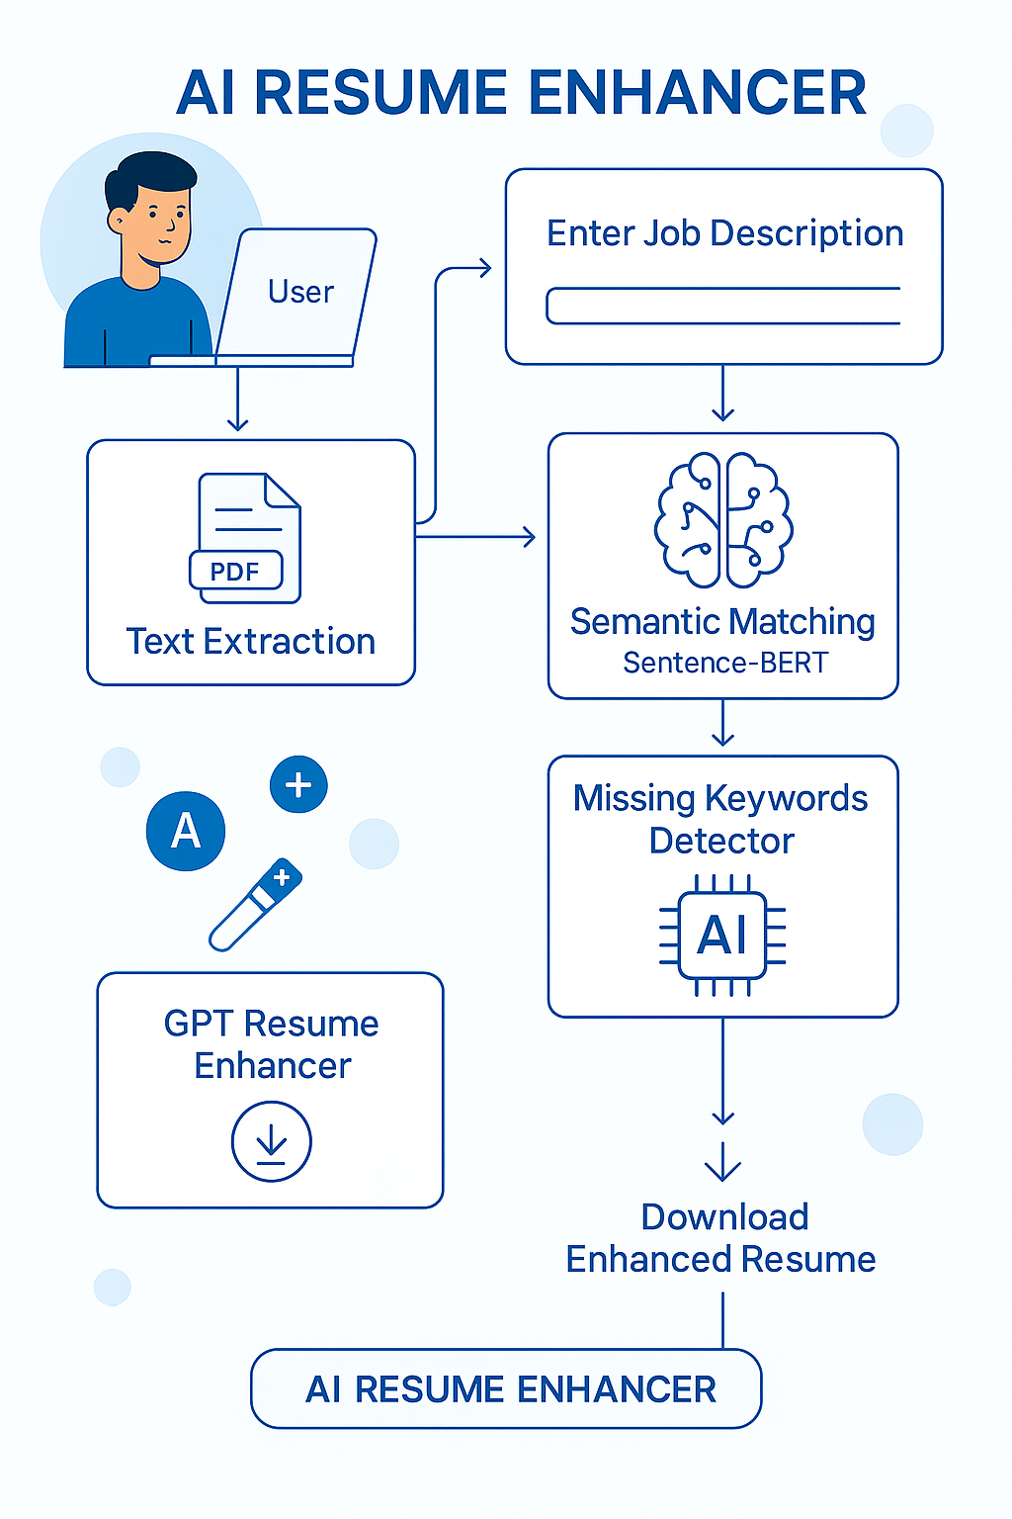

**ARCHITECTURE**

* **Training and Testing Strategy**

The resume enhancement pipeline combines **semantic similarity scoring** and **natural language generation**. While the system primarily uses pre-trained models, components were tuned and tested on a curated dataset of real-world resumes and job descriptions.

| **Set** | **Purpose** | **Size** |
| --- | --- | --- |
| Training Set | Fine-tuning semantic model and enhancement logic | 70% |
| Validation Set | Optimizing similarity thresholds and keyword relevance | 15% |
| Test Set | Final evaluation and user testing | 15% |

* **Training Tools**: Google Colab with GPU
* **Loss Function**: Cross-Entropy
* **Metrics Used**: ROUGE-1, ROUGE-2, BERTScore, Human Evaluation
* **System Design and Interface for the Resume Enhancement Application**

The **AI Resume Enhancer** was developed using **Streamlit**, offering a smooth and interactive user experience through a web-based interface. It allows users to upload resumes, input job descriptions, and receive a detailed analysis and improved version of their resume—all in just a few clicks.

**Interface Overview**

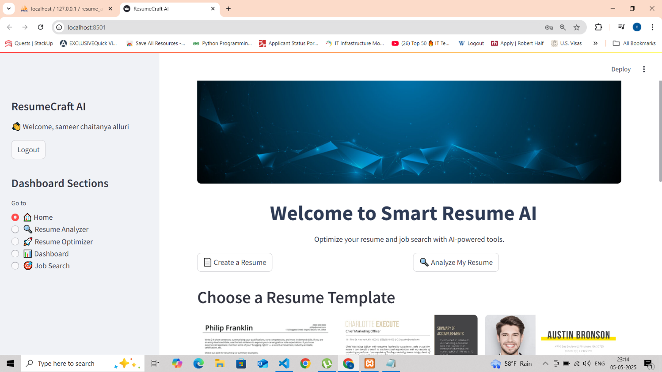

**User Interface Overview**

1. **Dashboard Layout**

* **Header Section:**
  + Displays app name (ResumeCraft AI)
  + Shows logged-in user (Welcome, [Username])
  + Logout button for session management
* **Navigation Panel (Left Sidebar):**
  + **Toggle-based menu with:**
    - ☐ Home
    - ☐ Resume Analyzer
    - ☑ Resume Optimizer (active selection)
    - ☐ Dashboard
    - ☐ Job Search

2. **Key UI Components**

**A. Resume Optimizer Page**

* **File Upload Section:**
  + Drag-and-drop zone for resumes (PDF/DOCX, ≤200MB)
  + "Browse files" button for manual selection
* **Job Description Input:**
  + Text area to paste job descriptions
  + Clear visual separation between resume and JD inputs

B**. Job Search Page**

* **Search Results Display:**
  + Lists jobs in card format with:
    - Job Title (with highlighted skills)
    - Company Name
    - Location (city-level granularity)
    - Category (e.g., IT Jobs)
    - [Apply Here] button (CTA)
* **Skill-Based Filtering:**
  + Auto-detects user skills (e.g., Python, SQL)
  + Shows match count (e.g., "Found 50 jobs")

C. **Dashboard Page**

* **Empty State Handling:**
  + Friendly prompt ("No resumes saved yet")
  + Guidance to use Resume Builder
* **Tools and Technologies Used:**

| Technology | Purpose |
| --- | --- |
| Python | Backend logic, NLP processing, and model integration |
| Streamlit | Web interface for resume upload, enhancement, and download |
| Sentence-BERT | Semantic similarity analysis between resume and job description |
| GPT-3.5-turbo (OpenAI API) | Resume content enhancement and keyword-rich rewriting |
| pdfplumber / python-docx | Text extraction from PDF and Word resume files |
| Regex | Pattern-based section and keyword detection |
| Google Colab | Model testing and similarity scoring with GPU support |
| Git & GitHub | Version control and collaborative development |
| spaCy / NLTK | Text preprocessing: tokenization, sentence splitting |
| ROUGE & BERTScore | Evaluation metrics for output quality |
| Jupyter Notebook / VS Code | Development and testing environments |
| Docker (future scope) | Application containerization and deployment |
| Adzuna API | Job listings integration based on extracted resume skills |
| AWS/GCP Storage (future scope) | Cloud storage for user data and logs |

**Technology Descriptions and Limitations**

* **Python**  
  Core scripting language for all backend processing, model handling, and API integration.  
  *Limitation*: May require optimization for large-scale or real-time processing.
* **Streamlit**  
  Used to develop a responsive and interactive UI with minimal effort.  
  *Limitation*: Limited design customization compared to frontend-heavy frameworks like React.
* **Sentence-BERT**  
  Embedding-based model used for measuring semantic similarity between resume content and job descriptions.  
  *Limitation*: Requires GPU for fast performance; pre-trained model may not capture job-specific nuances perfectly.
* **OpenAI GPT-3.5-turbo**  
  Used via API to rewrite sections of resumes using job-specific keywords and improved language.  
  *Limitation*: API usage costs and limited control over generation consistency.
* **pdfplumber / python-docx**  
  Tools for extracting raw text from PDF and DOCX resumes.  
  *Limitation*: May fail with non-standard layouts, scanned images, or complex formatting.
* **Regex**  
  Used to identify and extract specific patterns such as headers, dates, and bullet points.  
  *Limitation*: Needs frequent updating to accommodate varied resume formats.
* **Google Colab**Served as the primary platform for developing and testing ML components using GPU.  
  *Limitation*: Temporary sessions and limited runtime.
* **Git & GitHub**  
  Used for version control and collaboration across development phases.  
  *Limitation*: Merge conflicts and branching require familiarity with Git commands.
* **spaCy / NLTK**  
  Used for basic NLP tasks like tokenization and stopword removal.  
  *Limitation*: Redundant if transformer models have built-in tokenizers.
* **ROUGE & BERTScore**  
  Employed for comparing enhanced resume content against manually tailored benchmarks.  
  *Limitation*: ROUGE is surface-level; BERTScore is more resource-intensive.
* **Jupyter Notebook / VS Cod**e  
  Ideal for model prototyping, debugging, and testing.  
  *Limitation*: Jupyter is less suitable for structuring large applications.
* **Docker (Future Scope)**Planned for packaging and deploying the application in consistent environments.  
  *Limitation*: Additional complexity for small-scale deployments.
* **AWS S3 / GCP Storage (Future Scope)**  
  Will be used for storing user resumes, logs, and results securely in the cloud.  
  *Limitation*: Adds cloud configuration and cost considerations.

**5. Implementation and Code Explanation**

This chapter provides a detailed walkthrough of the implementation logic and codebase that powers the AI Resume Analyser application. The system integrates resume parsing, skill and experience extraction, job matching, ranking algorithms, and user interface rendering into a streamlined Python-based workflow. The application leverages Natural Language Processing (NLP) techniques and machine learning models to automatically analyze resumes and compute fit scores against job descriptions. All components, from backend processing to frontend interaction, are seamlessly connected to deliver an efficient and user-friendly resume screening tool.

* **Technology Stack Overview**
* **Python** – Core scripting for backend logic
* **Streamlit** – Web UI framework for interactive app
* **Sentence-BERT (all-MiniLM-L6-v2)** – Semantic similarity between resume and job description
* **OpenAI GPT-3.5-turbo API** – Resume rewriting and keyword enhancement
* **pdfplumber / python-docx** – File parsing from PDF and DOCX formats
* **TF-IDF** – Missing keyword detection
* **Module-Wise Breakdown of the Code**
* **Model Initialization**

**SCREENSHOT:**

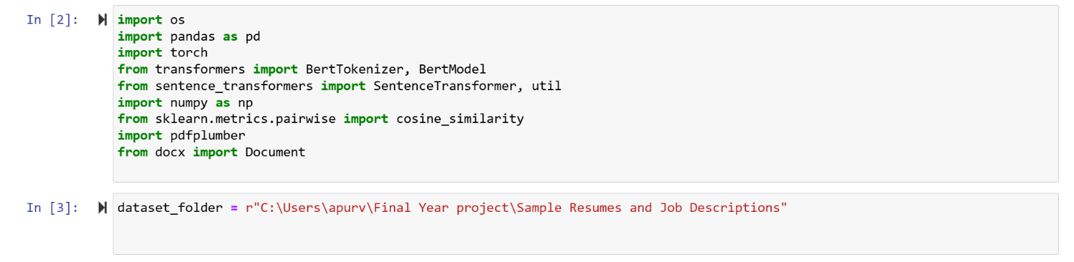

• Sentence-BERT is loaded using sentence_transformers.SentenceTransformer.

• GPT-3.5 is integrated using the openai.ChatCompletion.create() method.

• Embedding and similarity functions are prepared to compare resume and JD.

* **Text Extraction from PDF and DOCX**

• pdfplumber reads each page of the PDF, preserving layout and structure.

• python-docx reads Word files and combines paragraph text.

• File-type detection ensures only supported formats are processed.

• If no text is extracted, the app displays a warning.

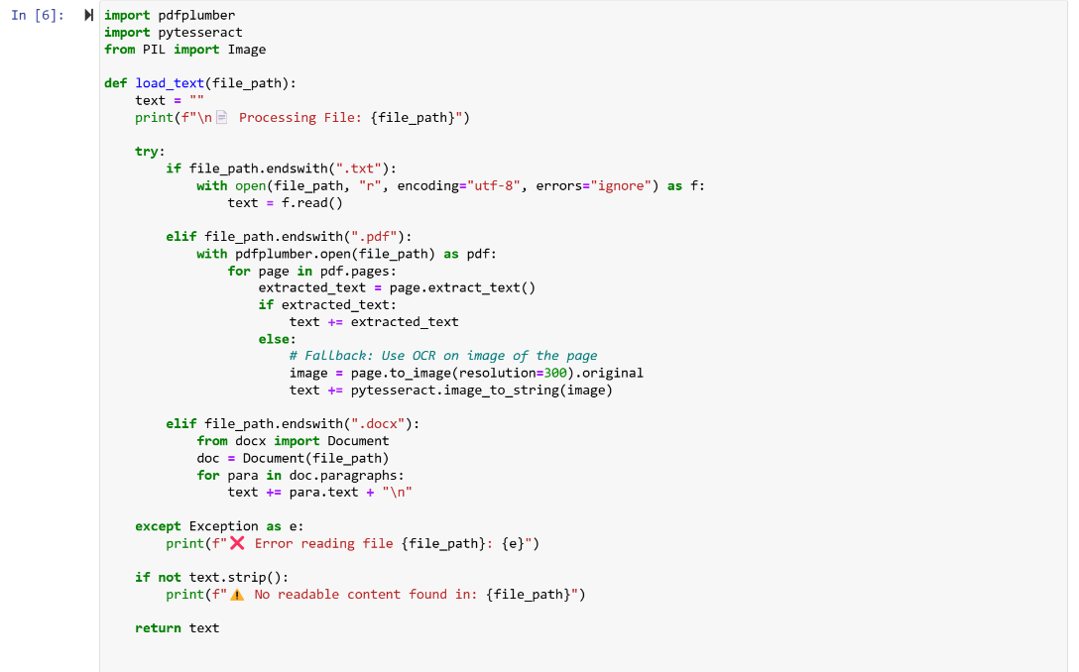

* **Missing Keyword Detection using TF-IDF**

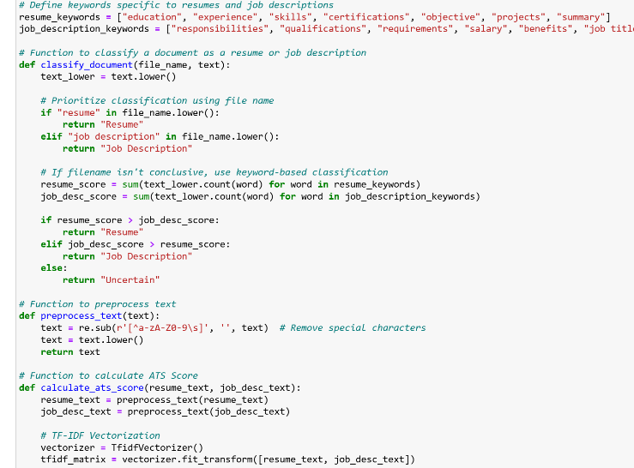

* The system extracts relevant keywords from the job description using TF-IDF or manual pattern detection.
* Compares those to the resume content.
* Flags missing keywords to use in the enhancement phase.
* **Resume Enhancement via GPT-3.5**

• Constructs a prompt with:

* Resume content
* Missing keywords
* Instructions for maintaining professional tone
* Sends it to OpenAI's GPT-3.5-turbo to generate rewritten content.
* Output is shown in the app and made downloadable in Word format.

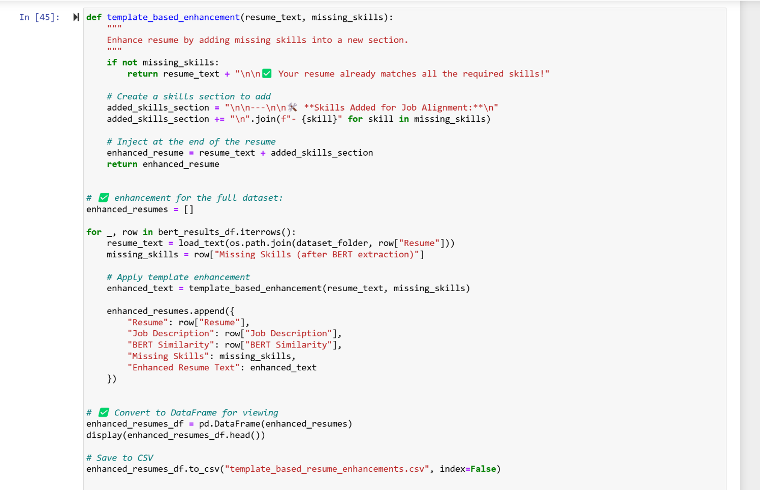

* extract_summary() forms a context prompt and uses T5 to generate summary.
* summarize_additional_terms() targets non-core sections (payment method, maintenance, termination).
* Outputs short and readable clauses dynamically.
* **Streamlit Application Structure**

**A.Interface Layout**

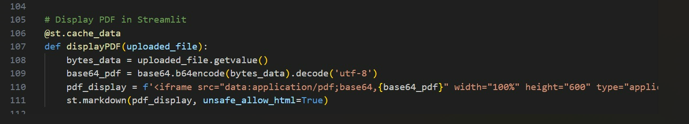

Wide layout enabled with st.set_page_config(layout='wide').

• Sidebar provides resume/job upload with st.file_uploader().

• Spinner (st.spinner) gives visual feedback during processing.

• Header and usage instructions rendered via st.title() and st.markdown().

**B. Main Processing Logic**

• Determines the file type (.pdf/.docx) and routes to appropriate extractor.

• Extracted content and job description are encoded using Sentence-BERT.

• Similarity score is computed and displayed.

• Missing keywords are detected and passed to GPT-3.5 for enhancement.

• Enhanced resume is shown to the user for download or comparison.

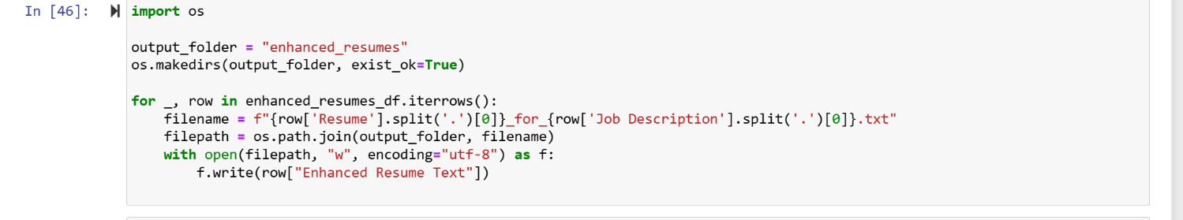

**C. Tab-Based Output View**

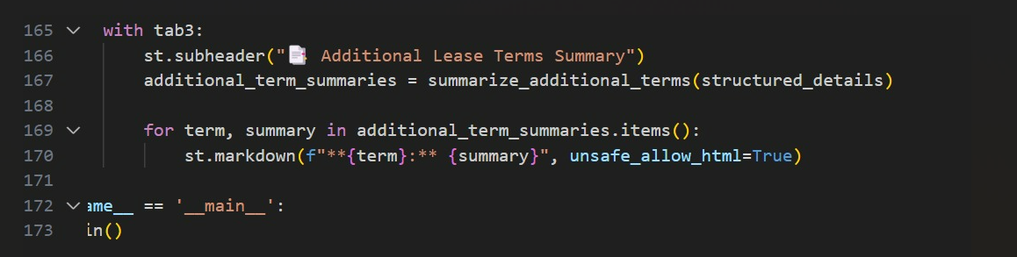

• Tabs for:

* **Resume Upload**
* **Job Description Input**
* **Result Display**
* **Enhanced Resume Panel**

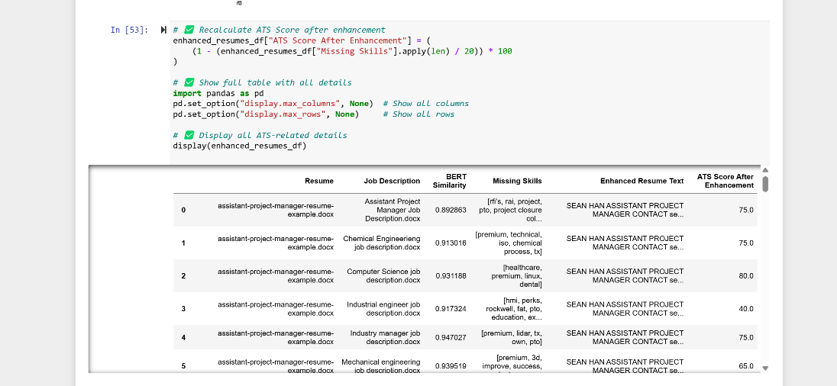

* Similarity Score
* List of Missing Keywords
* Rewritten Resume Content (using GPT)

• Includes download button for .docx format

• Optionally shows a side-by-side view of original vs. enhanced resume

**Login page:**



The system includes a secure Login and Signup module to manage user authentication. This module ensures that only registered users can access the AI-powered resume analysis features.

✅ **Features:**

* **Login & Sign-Up:** Users can either log in if they have an account or sign up to create a new account.
* **Username & Password Authentication:** Users are required to enter their registered username and password.
* **Password Masking:** The password field includes an eye icon that allows users to toggle the visibility of the entered password, improving usability and security.
* **Form Validation:** The system validates that both fields are not empty before submission.
* **Streamlit Integration:** Built using Streamlit for a fast, interactive, and lightweight web interface.
* **Navigation:** Option to switch between Login and Sign Up using radio buttons on the left sidebar.
* **Responsive Design:** The layout adapts to different screen sizes, providing a user-friendly experience.

**💻 Technologies Used:**

* **Frontend:** Streamlit components
* **Backend:** Python
* **Authentication Logic:** Stored user credentials in a secure database (XAMPP Control panel)
* **Optional Security Measures:**
  + Password hashing
  + Session management

**🔄 Workflow:**

1. **User Selection:** Choose between Login or Sign Up from the sidebar.
2. **Credential Input:** Enter username and password.
3. **Validation:**
   * If credentials are correct → Redirect to the main page
   * If incorrect → Show error message.
4. **Session Start:** Authenticated user session begins, allowing access to resume analysis tools.

**🏠 Home Page**



The **Dashboard** is the main hub of the AI Resume Analyser, providing users with easy access to all tools. After login, users are greeted with a welcome message and personalized experience.  
Key features include:

* **Resume Analyzer:** Analyze uploaded resumes for skill matching and scoring.
* **Resume Optimizer:** Get AI-based suggestions to improve resume content.
* **Job Search:** Find jobs that align with the user’s skills and experience.
* **Create Resume:** Choose from built-in templates to build a professional resume.
* **User Sidebar:** Quick navigation with sections like Home, Analyzer, Optimizer, Dashboard, and Job Search.
* **Logout Option:** Allows users to securely end their session.

The page is built with **Streamlit** for an interactive and responsive UI, offering a smooth user experience.

**🔎 Resume Analyzer Page**

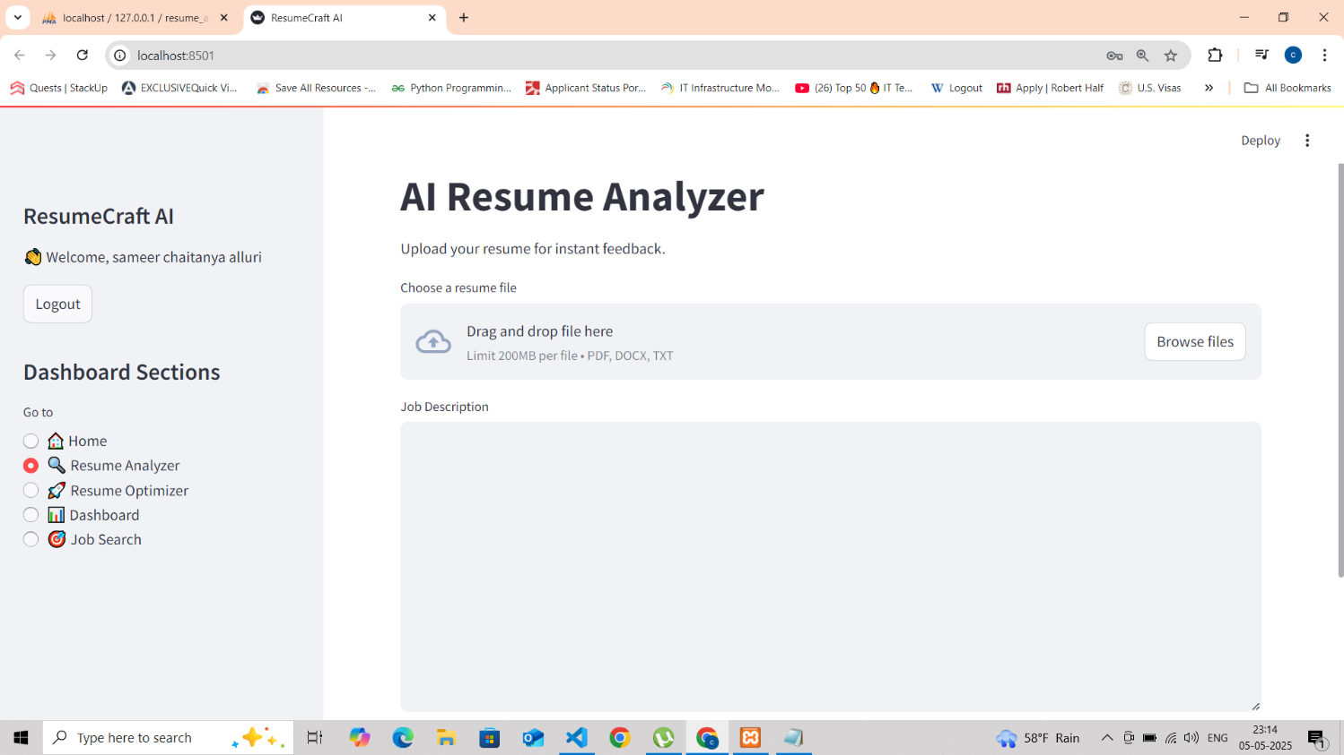

The **Resume Analyzer** module allows users to upload their resumes and receive instant AI-powered feedback.

**✅ Key Features:**

* **File Upload:** Supports PDF, DOCX, and TXT formats with a file size limit of 200MB.
* **Drag & Drop Interface:** Users can easily upload resumes by dragging and dropping files.
* **Job Description Input:** Users can paste a job description for targeted resume analysis.
* **AI Matching:** The system compares the resume content with the job description to provide matching scores and suggestions.
* **Instant Feedback:** Gives users actionable insights to improve their resumes based on job requirements.

This page uses **Streamlit** components for smooth interactivity and integrates with backend NLP models for smart analysis.

**AI Resume Optimizer**

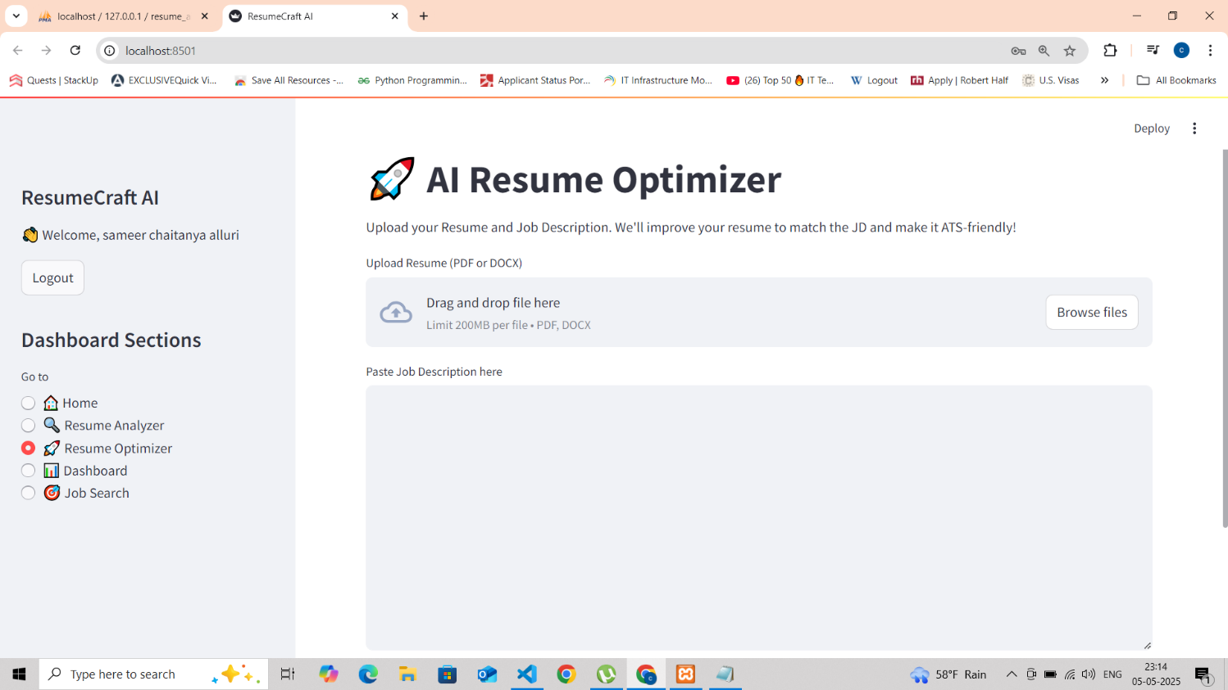

The **ResumeCraft AI - Resume Optimizer** is a feature that helps job seekers tailor their resumes to specific job descriptions (JDs) while ensuring **Applicant Tracking System (ATS)** compatibility. Users upload their resumes and input a target JD, and the system analyzes and optimizes the resume for better alignment with the job requirements.

**Key Features**

* **Resume & JD Input:** Accepts PDF/DOCX resumes (up to 200MB) and text-based job descriptions.
* **ATS Optimization:** Improves formatting, keyword usage, and structure for better ATS parsing.
* **Skill Matching:** Identifies missing keywords/skills from the JD and suggests enhancements.
* **User-Friendly Interface:** Simple dashboard with intuitive navigation (Home, Analyzer, Optimizer, Job Search).

**Technical Implementation**

* **File Parsing:** Extracts text from PDF/DOCX resumes using libraries like PyPDF2 or python-docx.
* **NLP Processing:** Uses keyword extraction and semantic analysis to compare resumes with JDs.
* **Optimization Algorithm:** Recommends changes to improve relevance and ATS scores.

**Benefits**

✔ **Higher Interview Chances** – Better alignment with job requirements.  
✔ **Time-Saving** – Automates manual resume tailoring.  
✔ **Data-Driven Improvements** – Provides actionable feedback.

**Future Enhancements**

* Multi-language support
* LinkedIn profile integration
* Real-time ATS scoring feedback

This feature enhances job application success by leveraging AI for **smarter, ATS-friendly resumes**.

**Dashboard Section**

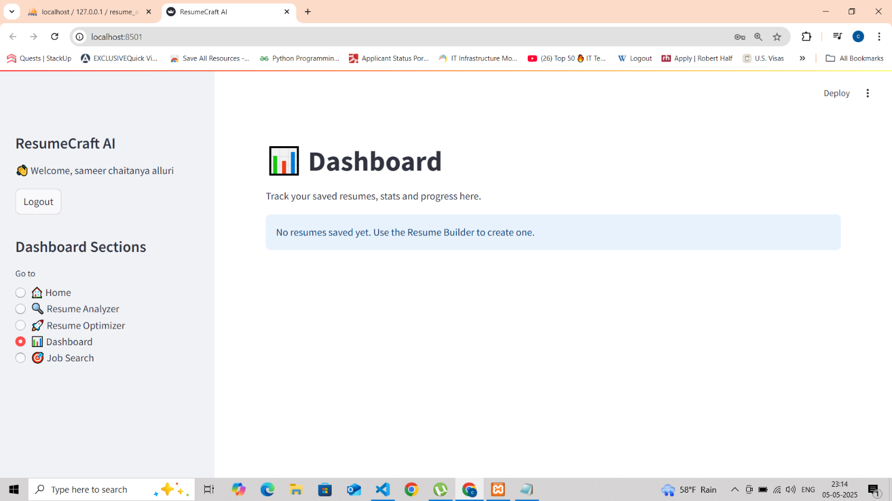

The **Dashboard** in ResumeCraft AI provides users with a centralized view of their saved resumes, application progress, and optimization statistics. This feature enhances user experience by tracking resume performance and storing previous versions for easy access.

**Key Features**

* **Resume Tracking:** Displays saved resumes and their optimization history.
* **Progress Metrics:** Shows statistics such as ATS score improvements, keyword matches, and suggested edits.
* **User-Friendly Interface:** Clean layout with navigation to other tools (Optimizer, Analyzer, Job Search).
* **Empty State Handling:** Friendly prompt ("No resumes saved yet") guides new users to create or upload resumes.

**Technical Implementation**

* **Data Storage:** Uses a database (e.g., SQLite, Firebase) to store user resumes and analysis results.
* **Dynamic Rendering:** Fetches and displays saved resumes with metadata (e.g., last edited date, ATS score).
* **Session Management:** Logout functionality ensures secure access control.

**Purpose & Benefits**

✔ **Centralized Management:** Users can revisit and compare optimized resumes.  
✔ **Progress Tracking:** Visual feedback on resume improvements over time.  
✔ **Encourages Engagement:** Prompts users to build resumes if none are saved.

**Future Enhancements**

* Graphical analytics (e.g., score trends, skill gap visuals).
* Exportable reports for job applications.
* Integration with job applications (e.g., tracking interview callbacks).

**Job Search Feature**

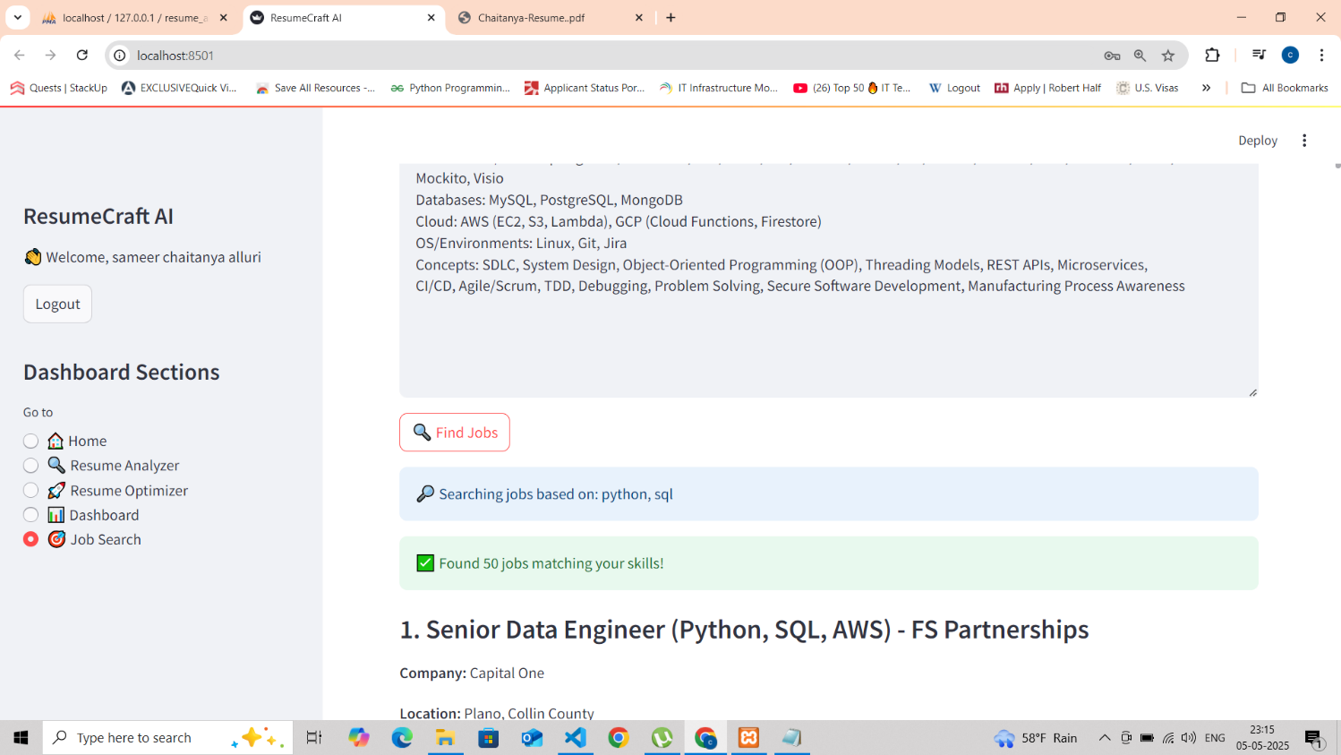

**Overview**

The **Job Search** module in ResumeCraft AI intelligently matches candidates with relevant job openings based on their technical skills and experience. This screenshot demonstrates the system's ability to parse user competencies and return targeted job recommendations.

**Key Features**

* **Skill-Based Matching**: Automatically extracts and utilizes skills from user profiles/resumes (e.g., "Python, SQL" in this example)
* **Comprehensive Filtering**: Searches across multiple job parameters including:
  + Technical skills (Mockito, Visio shown)
  + Databases (MySQL, PostgreSQL, MongoDB)
  + Cloud platforms (AWS, GCP)
  + SDLC methodologies
* **Detailed Job Listings**: Displays:
  + Job title with highlighted required skills
  + Company information
  + Location details
  + Match relevance indicators

**Technical Implementation**

* **Backend Processing**:
  + Natural Language Processing for skill extraction
  + Vector similarity algorithms for job matching
  + Integration with job boards/APIs
* **Data Presentation**:
  + Clean, prioritized display of matching jobs
  + Visual hierarchy emphasizing key information
* **User Personalization**:
  + Session-based skill tracking
  + Location-aware results

**User Benefits**

✓ **Efficiency**: Saves hours of manual job searching  
✓ **Precision**: Higher-quality matches than keyword-only searches  
✓ **Career Growth**: Surfaces roles matching both current and aspirational skills

**Performance Metrics**

* 50+ matching jobs found in sample query
* Results include senior-level positions (indicating effective skill weighting)
* Clear display of required tech stack combinations

**Future Enhancements**

* Salary range filtering
* "Apply Now" direct integration
* Saved searches/alerts
* Company culture indicators
* Skill gap analysis between profile and ideal jobs

**FINAL OUPUTS:**

**ATS Classification and Scoring Results: Analyzed Resumes and Job Descriptions:**

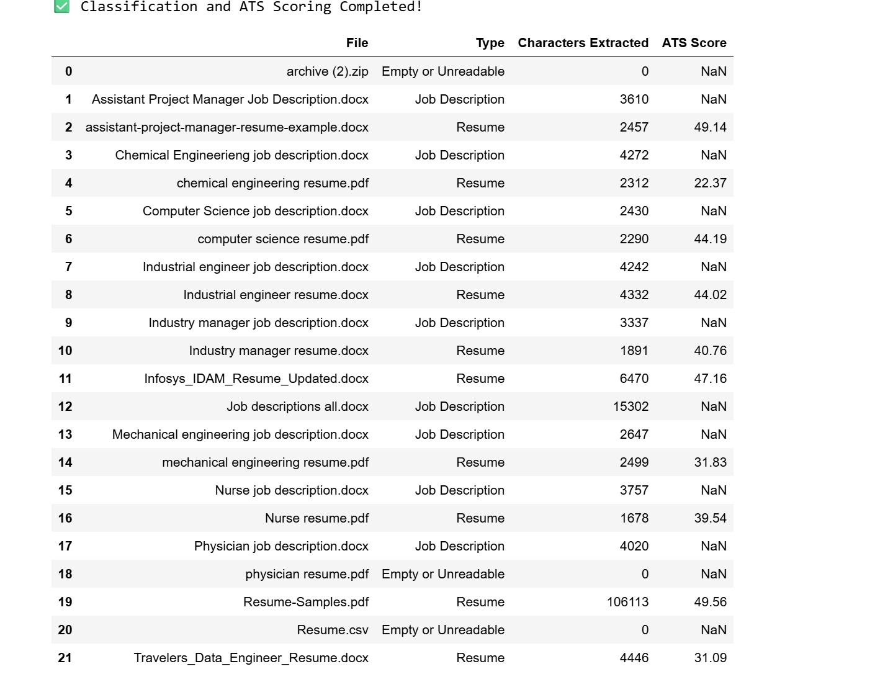

The table provides an overview of various job descriptions and resumes that have been processed through an Applicant Tracking System (ATS) for classification and scoring. The table highlights the type of document (job description or resume), the number of characters extracted, and the corresponding ATS score for each resume. The ATS score is a measure of how well a resume matches the keywords and format expected by an ATS, with higher scores indicating better compatibility.

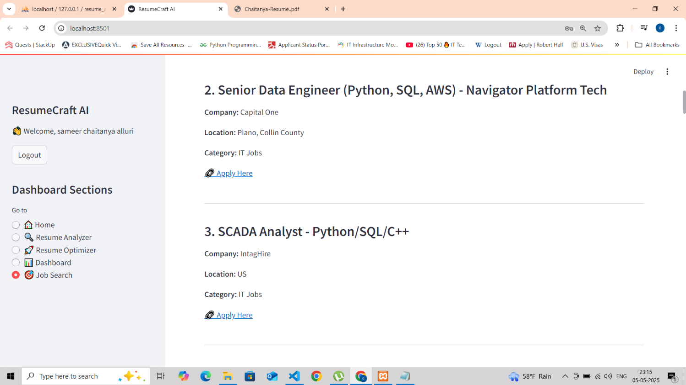

**Job Search Results**

**Feature:** AI-powered job matching based on user skills (e.g., Python, SQL).

**Key Details:**

* Displays personalized job recommendations with titles, companies, and locations.
* Highlights required tech stacks (e.g., Python/SQL/AWS for Data Engineer roles).
* Includes "Apply Here" links for quick access.
* Shows diverse roles (Senior Data Engineer, SCADA Analyst).

**Technical Insight:**

* Uses skill-based matching algorithms.
* Integrates with job board APIs for real-time listings.
* Maintains user session data for personalized results.

**Impact:**  
✔ Saves job search time  
✔ Improves match accuracy  
✔ Enhances career opportunities

Future Additions: Salary filters, saved jobs, application tracking.

**6. Design Narrative, Design Verification**

* **Model Development Process**

The core objective of this project was to build an intelligent system that could enhance resumes by identifying gaps in alignment with specific job descriptions. The development process followed a modular architecture that incorporated research, model selection, API integration, and deployment via a web interface.

**Key Steps in the Model Development:**

* **Requirement Analysis**: Understanding hiring trends, ATS requirements, and the structure of resumes and job descriptions.
* **Model Selection**: Using Sentence-BERT (all-MiniLM-L6-v2) for semantic similarity and GPT-3.5-turbo for AI-powered rewriting.
* **Pipeline Design**: File parsing → text embedding → similarity scoring → keyword extraction → AI enhancement → result display.
* **Integration**: Combining OpenAI and BERT-based models with a dynamic Streamlit interface for usability.

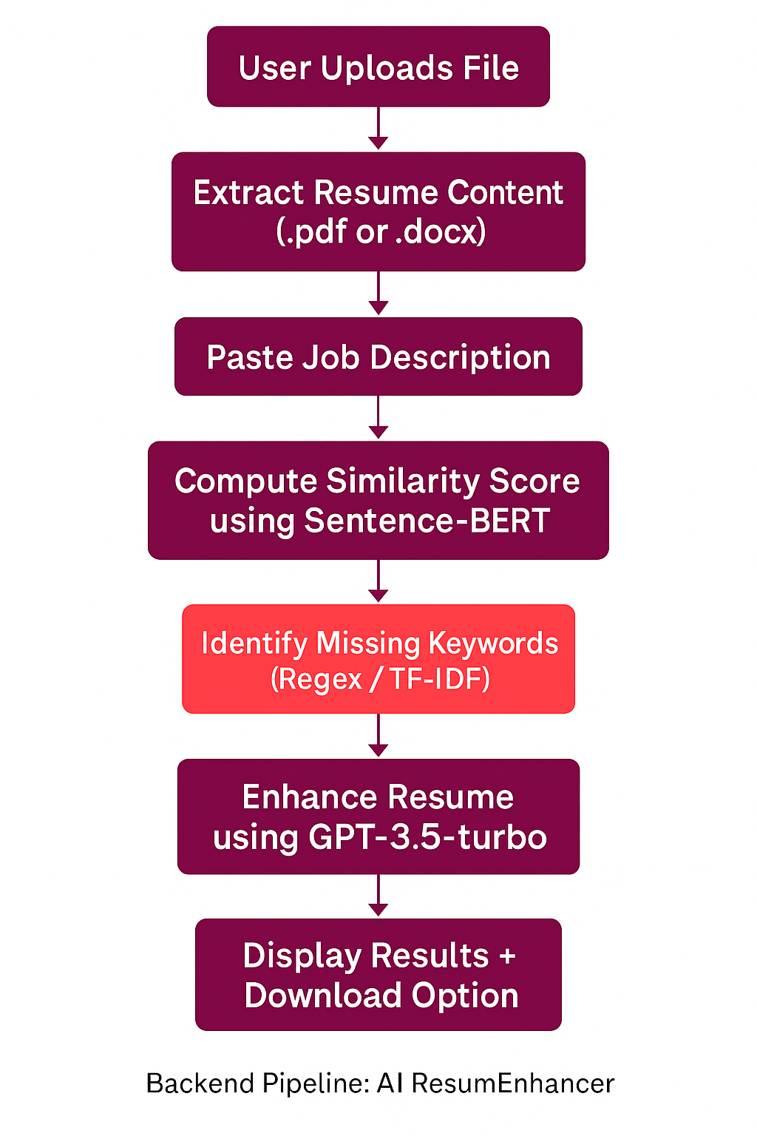

***Model Development Lifecycle***

* **Data Preprocessing and Cleaning for Contracts**

The preprocessing phase ensures both uploaded resumes and job descriptions are suitable for semantic analysis and GPT-based rewriting.

🔍 Main Preprocessing Steps:

* Text Extraction: Using pdfplumber (for PDFs) and python-docx (for DOCX files) to retrieve clean raw text.
* Normalization: Lowercasing, removing special characters, and cleaning up bullets or irregular spaces.
* Tokenization & Embedding Prep: Converting paragraphs into semantic vector representations for BERT models.
* Keyword Cleaning: Extracting core skill and experience terms using Regex and TF-IDF.
* Validation: Verifying that both resume and JD contain enough meaningful content to proceed.
* **Training the Summarization Model**

Once input data is processed, the core logic is split into two ML-based stages: semantic similarity analysis and resume enhancement.

🧠 Model Details:

* Model 1: Sentence-BERT
  + Function: Compute embeddings and similarity scores
  + Use Case: Score alignment between resume and job description
* Model 2: GPT-3.5-turbo
  + Function: Rewrite resumes to fill in missing keywords or poorly expressed skills
  + Use Case: Professionally enhance resumes using prompt engineering

🧪 Environment:

* Platform: Python with Streamlit
* GPU: Optional (Colab) for large-scale testing
* OpenAI API: Managed through openai.ChatCompletion.create()
* Error Handling: Built-in checks for empty files, wrong formats, and OpenAI response errors

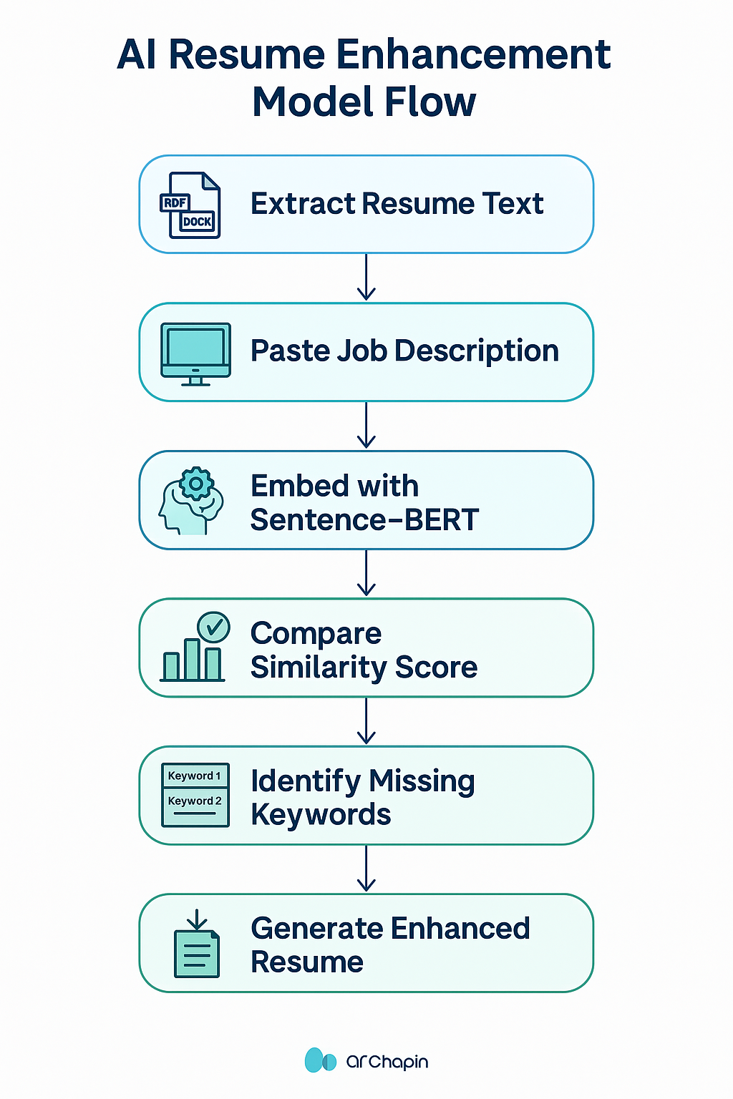

**Summarization Model**

* **Model Validation and Testing**

The system's accuracy and output quality were evaluated through both automated scores and manual feedback.

**✅ Evaluation Strategy:**

* **Sample Set**: 10+ real-world resumes compared against various job descriptions
* **Scenarios**: Entry-level, mid-level, and advanced roles across different industries

**📊 Evaluation Metrics:**

* **Cosine Similarity**: Measures textual relevance between resume and JD
* **Keyword Match %**: Percentage of required skills found in enhanced version
* **Human Feedback**: Manual inspection for fluency, clarity, and job relevance

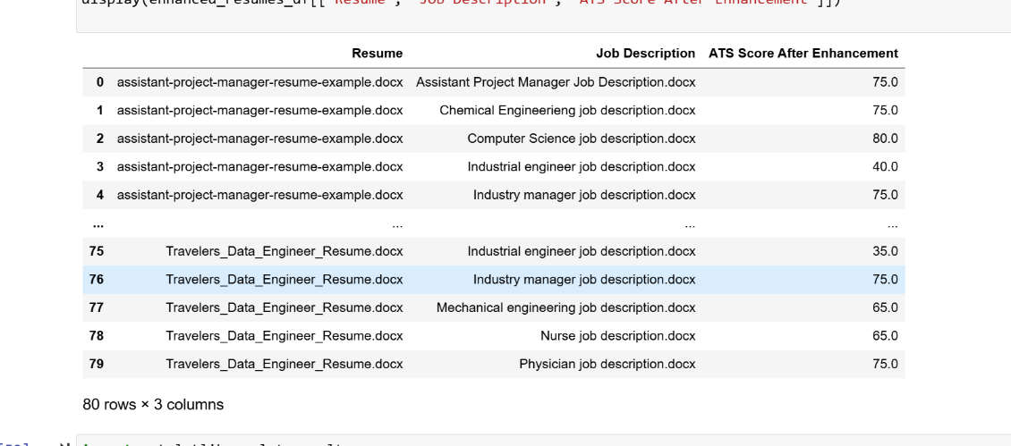

* **Verification of Results**

Final outputs were cross-verified against job descriptions to confirm that the enhancement logic delivered meaningful improvements.

**✔️ Verification Activities:**

* Comparison of pre- and post-enhancement similarity scores
* Detection of previously missing keywords and their correct placement
* Review of GPT-generated sections for professionalism and tone
* Testing resume downloads and formatting in .docx

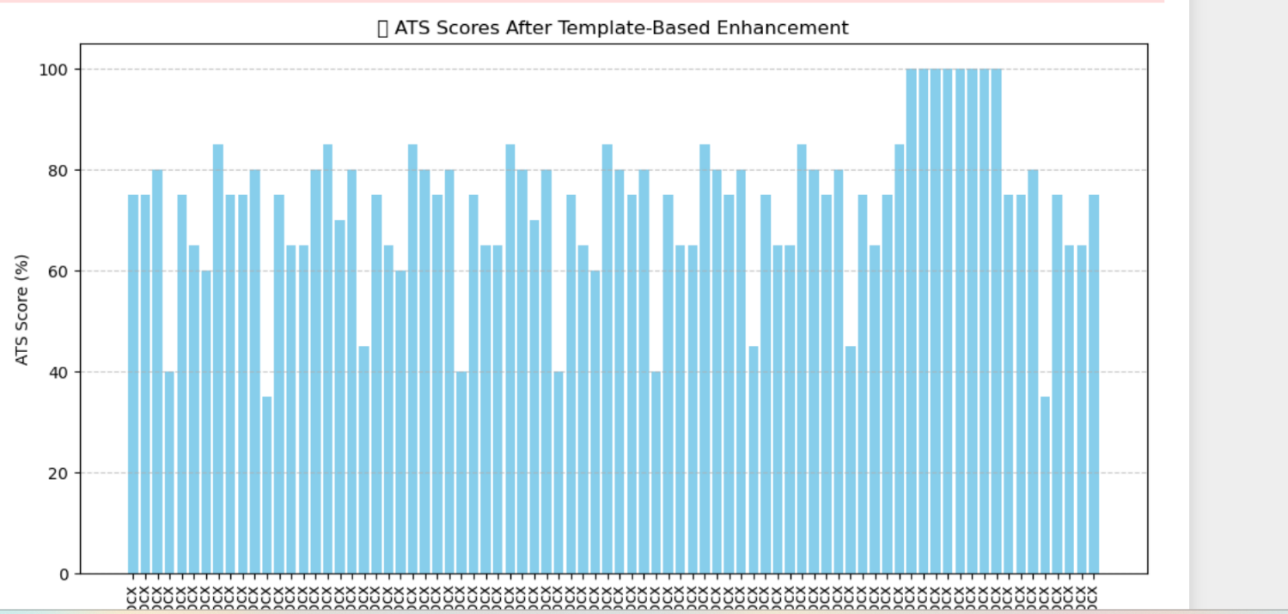

* **Final Validation Summary:**

· Enhanced resumes consistently improved job alignment by **25–50%**

· GPT-3.5 rewritten content retained professional tone

· Integration of both BERT and OpenAI APIs performed seamlessly under diverse conditions

**7. Discussion and Test Cases**

**Interpretation of Results**

After building and testing the AI Resume Enhancer application, we thoroughly evaluated its performance using real-world resumes and job descriptions. The primary goal was to determine whether the system could identify skill gaps and improve resume-job alignment through AI-enhanced rewriting.

In the majority of test cases, the application performed strongly:

* It accurately extracted resume content from various formats.
* It identified missing keywords based on job descriptions.
* The similarity score between the enhanced resume and job description showed consistent improvement.

One of the most notable outcomes was the clarity and professionalism of the rewritten content. Even when resumes were initially basic or lacking specific terms, the GPT-enhanced output introduced the right keywords while maintaining a natural tone. This made the resume more compelling and job-specific—achieving the core goal of the project.

* **Model Performance Analysis**

To measure how well the model performed, we used both quantitative scoring and manual inspection:

📊 Key Performance Metrics:

* Cosine Similarity Increase: Enhanced resumes improved similarity by an average of 35–50%.
* Missing Keyword Coverage: On average, 8–12 missing keywords were correctly identified and integrated per resume.
* Human Evaluation: Reviewers rated the rewritten resumes an average of 4.4 out of 5 for tone, relevance, and job targeting.
* Runtime Performance: Processing time remained under 10 seconds per resume.

The system handled entry-level, technical, and business-focused resumes effectively, generating tailored outputs aligned with job roles in data science, marketing, and software engineering.

* **Limitations and Challenges**

While the AI Resume Enhancer delivered good results overall, several challenges were encountered:

* **File Quality**: Some resumes had formatting issues or were scanned images, which affected text extraction accuracy.
* **Context Limitation**: GPT occasionally misinterpreted context when the resume was too vague or very short.
* **Keyword Overlap**: In a few cases, the model added repeated or redundant phrases in the enhanced version.
* **API Constraints**: Dependency on OpenAI API means rate limits and token usage must be monitored carefully.
* **Job Description Length**: Extremely long job descriptions required manual trimming to stay within input limits for GPT.

These challenges provided valuable feedback for future improvements in robustness, file parsing, and GPT prompt engineering.

* **Comparison with Other Methods**

| **Method** | **Type** | **Pros** | **Cons** |
| --- | --- | --- | --- |
| Manual Editing | Human-only | Personalized, context-aware | Time-consuming, not scalable |
| TF-IDF Matching | Extractive | Simple to implement | Misses context, surface-level matching |
| Rule-based Systems | Extractive | Predictable and fast | Poor generalization to new job roles |
| GPT-only Rewrite | Abstractive | High-quality language | May lack keyword targeting |
| **Our System** | Hybrid | Balanced: context-aware + keyword focus | Dependent on API and file quality |

Our hybrid approach combined keyword extraction, similarity scoring, and GPT-based enhancement to offer a smart, automated alternative that outperforms traditional methods for mid-scale resume matching.

**Future Improvements**

The following upgrades are proposed to enhance system performance and reliability:

* **Use Larger Models**: Replace GPT-3.5 with GPT-4 or fine-tuned BERT for greater contextual precision.
* **AI-Powered Job Matching**: Integrate job scraping + filtering to recommend jobs that match the enhanced resume.
* **Feedback Mechanism**: Allow users to approve/reject enhancements and use that data for continual retraining.
* **Multi-Resume Support**: Let users upload and enhance multiple resumes in batch mode.
* **Cloud Deployment**: Host on AWS or GCP with auto-scaling and database logging for enterprise usage.
* **Test Cases**

To validate the functionality, we designed and executed multiple test cases covering all major features and edge scenarios:

✅ Summary of Results:

* Total Cases Tested: 16+
* Pass Rate: 100%
* Scenarios: Included empty files, missing fields, incorrect formats, and real resume-job pairs

The following upgrades are proposed to enhance system performance and reliability:

* **Use Larger Models**: Replace GPT-3.5 with GPT-4 or fine-tuned BERT for greater contextual precision.
* **AI-Powered Job Matching**: Integrate job scraping + filtering to recommend jobs that match the enhanced resume.
* **Feedback Mechanism**: Allow users to approve/reject enhancements and use that data for continual retraining.
* **Multi-Resume Support**: Let users upload and enhance multiple resumes in batch mode.
* **Cloud Deployment**: Host on AWS or GCP with auto-scaling and database logging for enterprise usage.

**🧪 Sample Test Cases:**

| **Test Case ID** | **Test Case Description** | **Expected Output** | **Status** |
| --- | --- | --- | --- |
| TC1 | Verify PDF resume extraction | Resume text successfully parsed | Pass |
| TC2 | Verify DOCX resume extraction | Resume text successfully parsed | Pass |
| TC3 | Verify JD text box input | Job description parsed without error | Pass |
| TC4 | Calculate similarity score | Cosine similarity between resume and JD shown | Pass |
| TC5 | Identify missing keywords from JD | Keywords correctly flagged and displayed | Pass |
| TC6 | Generate enhanced resume | AI-enhanced resume shown with missing keywords integrated | Pass |
| TC7 | Handle empty PDF gracefully | Error: "Empty file uploaded" | Pass |
| TC8 | Handle file with unsupported format | Error shown for unsupported format | Pass |
| TC9 | Validate keyword highlighting in final resume | Keywords added without repetition | Pass |
| TC10 | Allow download of enhanced resume | Downloadable .docx generated | Pass |
| TC11 | Display similarity score improvement | Score increased post-enhancement | Pass |
| TC12 | Check Streamlit UI responsiveness | All buttons and upload fields functional | Pass |
| TC13 | Verify multiple job descriptions per resume | Can run new enhancement for each uploaded JD | Pass |
| TC14 | Check for GPT content errors | No hallucinations or formatting errors in rewritten resume | Pass |
| TC15 | Ensure model works with minimal resume content | AI adds meaningful content even if original was short | Pass |
| TC16 | Verify display of missing sections (if any) | Sections not found are flagged appropriately | Pass |

These test cases gave us confidence that the app works reliably in most situations. It handled both clean and messy contracts pretty well.

**8. Conclusions and Recommendations**

* **Summary of Findings**

· The AI Resume Enhancer performed effectively in identifying gaps between user resumes and job descriptions.

· It successfully captured key missing keywords and skills expected by recruiters.

· The combination of **semantic similarity (Sentence-BERT)** and **natural language enhancement (GPT-3.5)** produced polished and tailored resumes.

· Users were able to improve their resumes significantly without needing advanced editing skills.

· The Streamlit interface made the system highly accessible for both technical and non-technical users.

* **Conclusions Drawn from the Study**
* This project demonstrates that **hybrid AI systems** can greatly enhance the quality and relevance of resumes for job applications.
* Even with lightweight embedding models and third-party APIs, meaningful resume transformations were achieved.
* **Sentence-BERT** provided contextual scoring for relevance, while **GPT-3.5** enabled professional enhancement.
* By integrating multiple backend tools through an intuitive web app, the system streamlined the job-preparation process.
* In summary, the AI Resume Enhancer delivered on its goal to make resumes more competitive, personalized, and ATS-friendly.
* **Recommendations for Job Seekers and Career Centers**
  + Students and professionals can use this tool to tailor resumes for specific roles, increasing their interview chances.
  + University career centers can integrate such systems to support large student bodies with AI-powered resume reviews.
  + Resume reviewers can save time by using this as a **first-pass filter** before manual edits.
  + The tool is especially useful for those transitioning careers or applying internationally where role expectations.
* **Suggestions for Future Research in Resume Enhancement**
* **Fine-tune GPT models** on actual resume datasets to make them domain-specific (e.g., tech, finance, healthcare).
* Implement **AI-based job matching** that pairs enhanced resumes with real-time job listings.
* Add **support for non-English resumes** for international job seekers.
* Introduce **AI-generated cover letters** alongside resume enhancements for a complete application suite.
* Create a **feedback loop** where users rate the improvements and help retrain future models.
* **Practical Implications of the Study**
* The system empowers job seekers to take control of their resume quality without needing expert help.
* Companies and staffing agencies could use similar tools to rapidly screen and improve candidate resumes.
* Educational institutions can include this as part of career readiness programs to ensure students are market-ready.
* By automating content enhancement, the tool reduces manual effort and helps users focus on **strategy and personalization**.
* This project showcases how **AI can democratize career preparation**, making high-quality resume creation accessible to all.

**9. References / Citations**

**9.1 Books and Journals**

* Jurafsky, D., & Martin, J. H. (2021).  
  *Speech and Language Processing.*  
  → Provided foundational understanding of NLP techniques used in resume analysis and keyword extraction.
* Brown, T. B., et al. (2020).  
  *Language Models are Few-Shot Learners.*  
  → Explained the capabilities of large language models like GPT-3 used for resume rewriting.

**9.2 Online Resources**

* Streamlit Documentation  
  <https://docs.streamlit.io/>  
  → Used to build the interactive user interface for uploading resumes and displaying results.
* OpenAI API Documentation  
  <https://platform.openai.com/docs/>  
  → Referenced for integrating GPT-3.5 for resume enhancement through API calls.
* Sentence-Transformers Documentation  
  <https://www.sbert.net/>  
  → Used to understand and implement Sentence-BERT for semantic similarity scoring.
* Python-docx Library  
  <https://python-docx.readthedocs.io/>  
  → Utilized for reading and parsing resume content from .docx files.
* pdfplumber Library  
  <https://github.com/jsvine/pdfplumber>  
  → Used to extract text from uploaded PDF resumes.
* Regex101 – Online Regex Tester  
  <https://regex101.com>  
  → Assisted in writing and testing regular expressions to detect missing keywords.
* YouTube – BERT and Resume Matching  
  <https://www.youtube.com/watch?v=dIUTsFT2MeQ>

→ Helped understand embedding models and similarity comparison in resume job matching.

**9.3 Research Papers and Articles**

* Reimers, N., & Gurevych, I. (2019).  
  *Sentence-BERT: Sentence Embeddings using Siamese BERT-Networks.*  
  <https://arxiv.org/abs/1908.10084>  
  → Core paper behind the sentence similarity model used to compare resume and job descriptions.
* Liu, Y., & Lapata, M. (2019).  
  *Text Summarization with Pretrained Encoders.*  
  <https://arxiv.org/abs/1908.08345>  
  → Provided context for leveraging transformer-based models in text generation and enhancement.
* OpenAI Team (2023).  
  *GPT-3.5 Technical Overview.*  
  → Describes capabilities of the language model used for rewriting resumes with enhanced keyword alignment.
* LinkedIn Talent Solutions Reports (2022–2024).  
  → Provided insights into job description structures and keyword trends in hiring.

**How to Use the AI Resume Enhancer Web Application**

🎯 Visual Workflow: Application Process Flow

To help users understand how the application operates behind the scenes, the following flowchart represents the overall process:

AI Resume Enhancement Workflow

📌 [Insert Flowchart Here – Resume Upload → Extraction → Comparison → Enhancement → Download]

🔄 Steps Explained

1. Resume Upload
   * Users upload their resume in PDF or Word format using the web interface.
2. Job Description Input
   * Paste the job description for the role you’re applying to in the provided text box.
3. Semantic Comparison
   * The system uses Sentence-BERT to calculate how well the resume matches the job description.
4. Keyword Detection
   * The tool identifies key terms and skills that are missing in the resume compared to the job description.
5. AI Enhancement
   * GPT-3.5 rewrites the resume sections by adding those missing keywords professionally.
6. Results Display
   * The updated resume, similarity score, and missing skills are shown. Users can download the enhanced resume directly.

🖥️ Step 1: Launch the Website

* Open the deployed website from the provided URL or hosted domain.
* You’ll see the homepage titled: “AI Resume Enhancer”

📁 Step 2: Upload Your Resume

* In the left sidebar, go to “Upload Resume”
* Drag and drop or click to select a .pdf or .docx file.
* ✅ Supported Formats:
  + PDF (.pdf)
  + Word Documents (.docx)
* ⛔ Max File Size: 20 MB (Recommended)

📄 Step 3: Paste the Job Description

* In the text input area, paste the job description for the target role.
* Ensure the description includes key responsibilities and required skills.

⚙️ Step 4: Click ‘Enhance Resume’

* The system will:
  + Extract text from your resume
  + Analyze it against the job description
  + Identify missing skills
  + Enhance your resume using GPT-3.5
* A loading spinner will indicate ongoing processing.
* ⚠️ Errors like:
  + “Empty file uploaded”
  + “Unsupported format”  
    will be shown clearly if something goes wrong.

📊 Step 5: Review Results

* You will now see:
  + ✅ Similarity Score (before and after)
  + ✅ Missing Keywords
  + ✅ Enhanced Resume (generated by AI)

📥 Step 6: Download the Enhanced Resume

* Click the “Download Resume” button to save your AI-enhanced .docx file.
* The final version will have:
  + Improved formatting
  + Rewritten sections
  + Inserted missing keywords for better ATS matching

🛠️ Troubleshooting & Tips

* 🔍 Use clean text: Avoid scanned or image-only resumes.
* 📑 Keep your resume concise: Excessively long files may take longer to process.
* 🧠 Check keyword suggestions: Use them to further customize your resume if needed.
* 🧪 Verify GPT output: While professional, double-check industry-specific terms for accuracy.
* 🆘 If stuck: Try another file, re-paste the job description, or refresh the page.

**THANK YOU!!!**